CV of Tanmay Sarma

Name: Tanmay Sarma
Designation: Assistant Professor
Address for Communication (office): 3rd Floor, School of Pharmaceutical Sciences building, Girijananda Chowdhury University, Hathkhowapara, Azara, Guwahati, Assam, India-781017
Mobile No.: +91-9678246903
WA No: +91-9678246903
Email: tanmay_pharmag@gcuniversity.ac.in

Date of Birth: 23/07/1996
Educational Qualifications:
Sl. No | Examination Passed | Year of passing | Board / Council /University | Specialization
1 | HSLC/10th Std. | 2013 | Board of Secondary Education, Assam
2 | HSSLC/10+2 Std. | 2015 | Assam Higher Secondary Education Council | Science
3 | Bachelor of Pharmacy | 2019 | Assam Science and Technology University | Pharmaceutical Sciences
4 | Master of Pharmacy | 2022 | Assam Science and Technology University | Pharmacology
6 | Ph. D. (Pharmaceutical Science) | Pursuing | Girijananda Chowdhury University | Pharmaceutical Sciences

Languages known: English, Assamese, Hindi
(Read, Write & Speak)

Academic/ Administrative Experience:
- Assistant Professor, The Assam Royal Global University, Guwahati, Assam (August 2022-January 2026)
- Assistant Professor, Girijananda Chowdhury University, Guwahati, Assam (February 2026 -Present)
- Assistant Superintendent of Semester-End Examination, The Assam Royal Global University, Guwahati, Assam (December 2023-December 2025)
- Supervised 3 UG project theses
List of Publications:
- Nooreen Z, Wal A, Shukla A, Badarinath AV, Kumar N, Sarma T, Khan A, Gasmi A. Emerging DNA-and RNA-based therapeutic strategies in hepatocellular carcinoma: A molecular approach to precision medicine. Letters in Drug Design & Discovery. 2026 Jan 15:100268. https://doi.org/10.1016/j.lddd.2025.100268
- Judder MI, Islam M, Kaur H, Rahman R, Deka K, Kapil MJ, Pathak BJ, Sarma T, Islam MM. Therapeutic Trends in Diabetes Management: A Review on Oral Hypoglycemic Agents (OHAs) Utilization in Tertiary Care. Cardiovascular & Hematological Disorders-Drug Targets. 2025. 10.2174/011871529X414055250924050309
- Chakraborty DD, Chakraborty P, Sarma T, Hazarika N, Bania T, Rynjah M. Bioactive Compounds Aimed at the AMPK Pathway: A Window into their Therapeutic Potential. Curr. Signal Transduct. Ther. Nov 1, 2024. http://dx.doi.org/10.2174/0115743624331249241025024548
- Shil D, Sarma T, Roy SD, Chakraborty J, Das SR, Das T, Rohman TA. Exploring Quality Control Standards and Potential Antibacterial Property of Different Extracts of the Root of Physalis minima L. Int. J. Res. Pharm. Sci. 2021;12:2350-60. doi: 10.26452/ijrps.v12i4.4868
- Bharali A*, Deka B, Sarma H, Sarma S, Ahmed A, Bhattacharjee B, Das G, Das B, Upadhyaya M, Phukan M, Kalita K, Gogoi B, Sarma T, “Integrating Recommendations to Improve Treatment Outcomes in the Clinical Management of Allergic Conjunctivitis”. Pharmaceutical and Biosciences Journal, 9(3), 2021, pp 22-40. https://doi.org/10.20510/pbj/9/i3/1364
- Bhargab BD, Dash B, Newar A, Ahmed A, Bharali A, Bordoloi B, Rohman TA, Bingari B, Bhattacharjee B, Sadhukan P, Ikbal AM, Sarma T. Coronavirus disease 2019: A comprehensive review on recent clinical updates and management tools for pharmacists. Pharmaceutical and Biosciences Journal. 2021 May 9:01-21. https://doi.org/10.20510/pbj/9/i3/1363

Book Chapter:
- Sarma T, Das T, Saha D, Das SR, Mishra SB, Singh AK, Chanda I. Overview of Functional Foods and Their Impact On Osteoporosis. In Applications of Functional Foods in Disease Prevention, 2024 Jan 9 (pp. 293-324). Apple Academic Press. https://doi.org/10.1201/9781003395737

Research Experience:
- Doctoral thesis guided: N/A
- Research & Consultancy Projects: NIL
Membership of Professional bodies: NIL
Award, Fellowship & Recognition: NIL
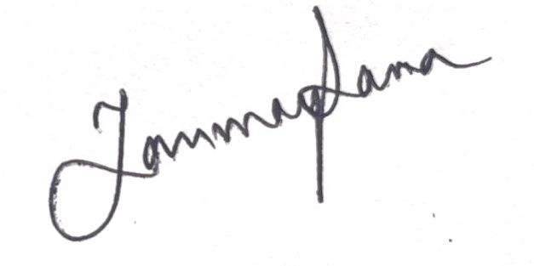
Date: 10/02/2026 Tanmay Sarma

